2.13. PROJECTS

# 2.13 PROJECTS

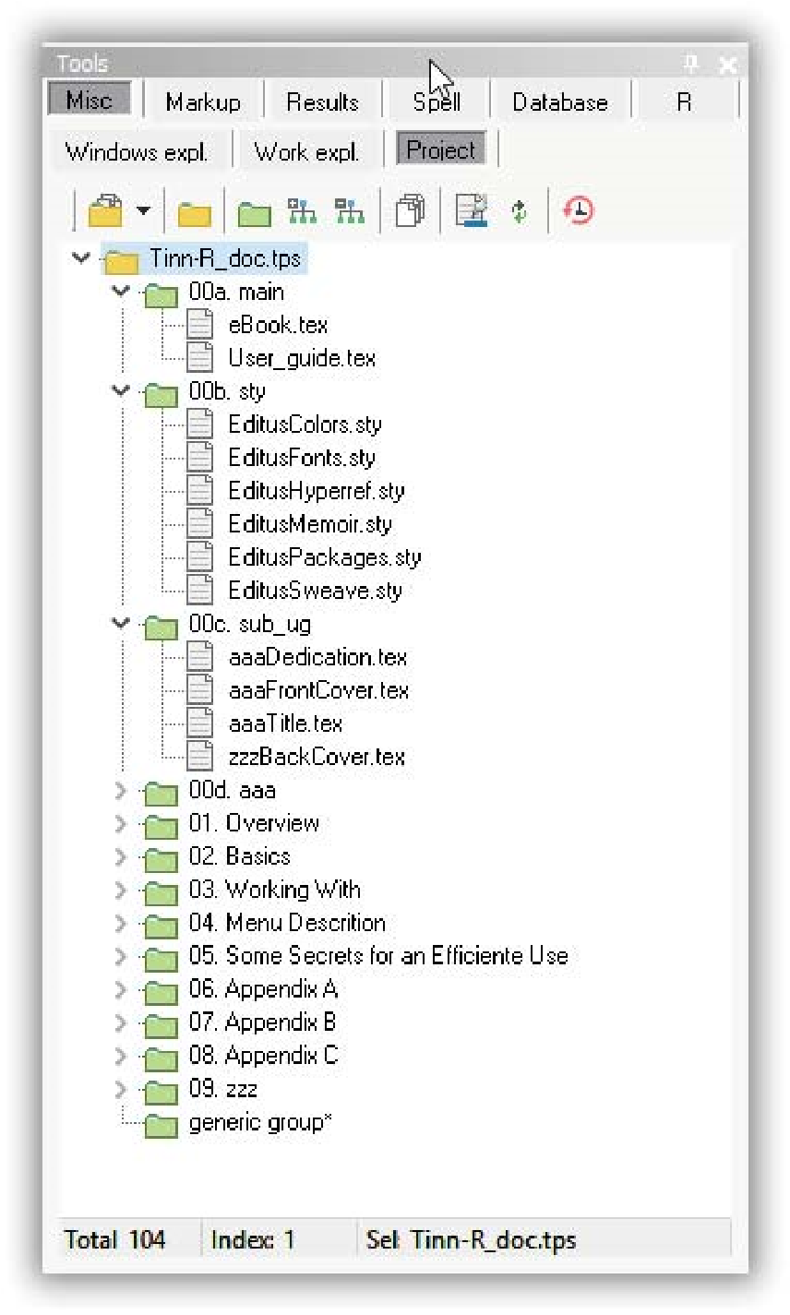

FIGURE 2.43: Tinn-R: Projects.

## Overview

A Tinn-R project (Figure 2.43) is a container for different types of editable files associated with a single task, for example, program files, data files, and text files. Files in similar categories can be grouped as Tinn-R groups within the project much like folders and subfolders. This saves you looking for and opening each of the files individually every time you start working. Simply double click on any file in the project or group (Figure **??**) visible in the Tools/Misc/Project pane and it will open under a new(s) tab(s) in Tinn-R.

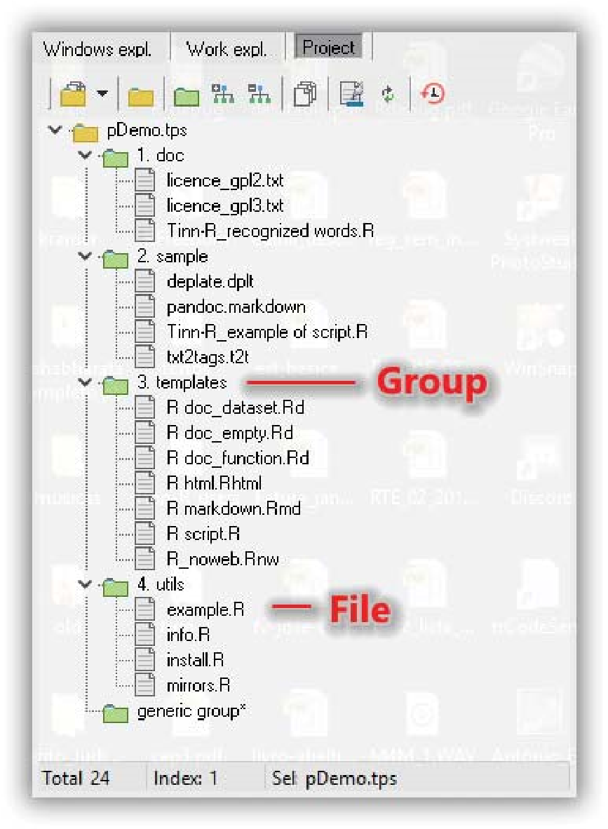

FIGURE 2.44: Tinn-R: Projects, groups and files.

You can also drag the object (entire project, group, or individual file) to the editor. Doing so will open the corresponding files for viewing in the editor.

Uneditable files (not ASCII/ANSI/UTF-X, such as PDF, PNG, etc) can be included in a project if you will benefit from the listing, but they are not correctly viewed in the editor.

## Opening the demo project

First, to see a project, you must open the Tools pane: View/Tools/Tools (CTRL+F8 by default) and choose the page Misc/Project.

You should find a demonstration project (pDemo.tps) at the second (left to right) yellow-brown project icon. The option Open demo (Figure 2.45) will open a didactic demo project. You can play around with it to get the general idea.

2.13. PROJECTS

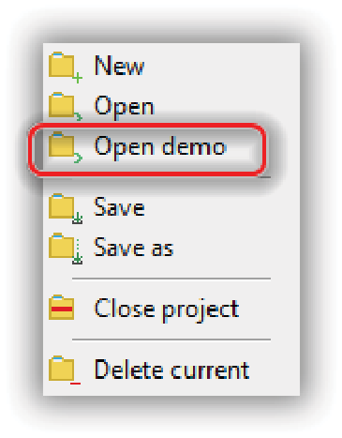

FIGURE 2.45: Tinn-R: Project demo.

Once you have opened the first project, you can use the first yellow-brown file-card icon whenever you wish to open a project from the displayed list.

## Creating your projects

To start your own project, click the smaller yellow-brown file-card icon, then New.

The new project will be stored as a .tps file. Add groups to the project with the green file-card icon. Add files to a group, or directly to the project itself, with the multiple-sheets icon, then click on Add. Files can be selected and dragged and dropped to change the groupings. Groups can be renamed by highlighting the group name, then right clicking. Groups can be expanded and contracted all at once with two other icons. You can close the Tools pane if it is getting in the way with |X| at the top right. Later, reopen it, and your project will still be present.

## Working with the project in graphical mode

For small projects, changing the project structure is preferable, for example, to add or exclude files, change groupings, rename objects directly in graphical mode using the taskbar buttons of the project and pop-up menus available. They are self-explanatory.

## Working with the project in text mode

To create or edit projects with many groups, and/or files, editing in text mode is usually more productive than in graphical mode (Figure 2.46).

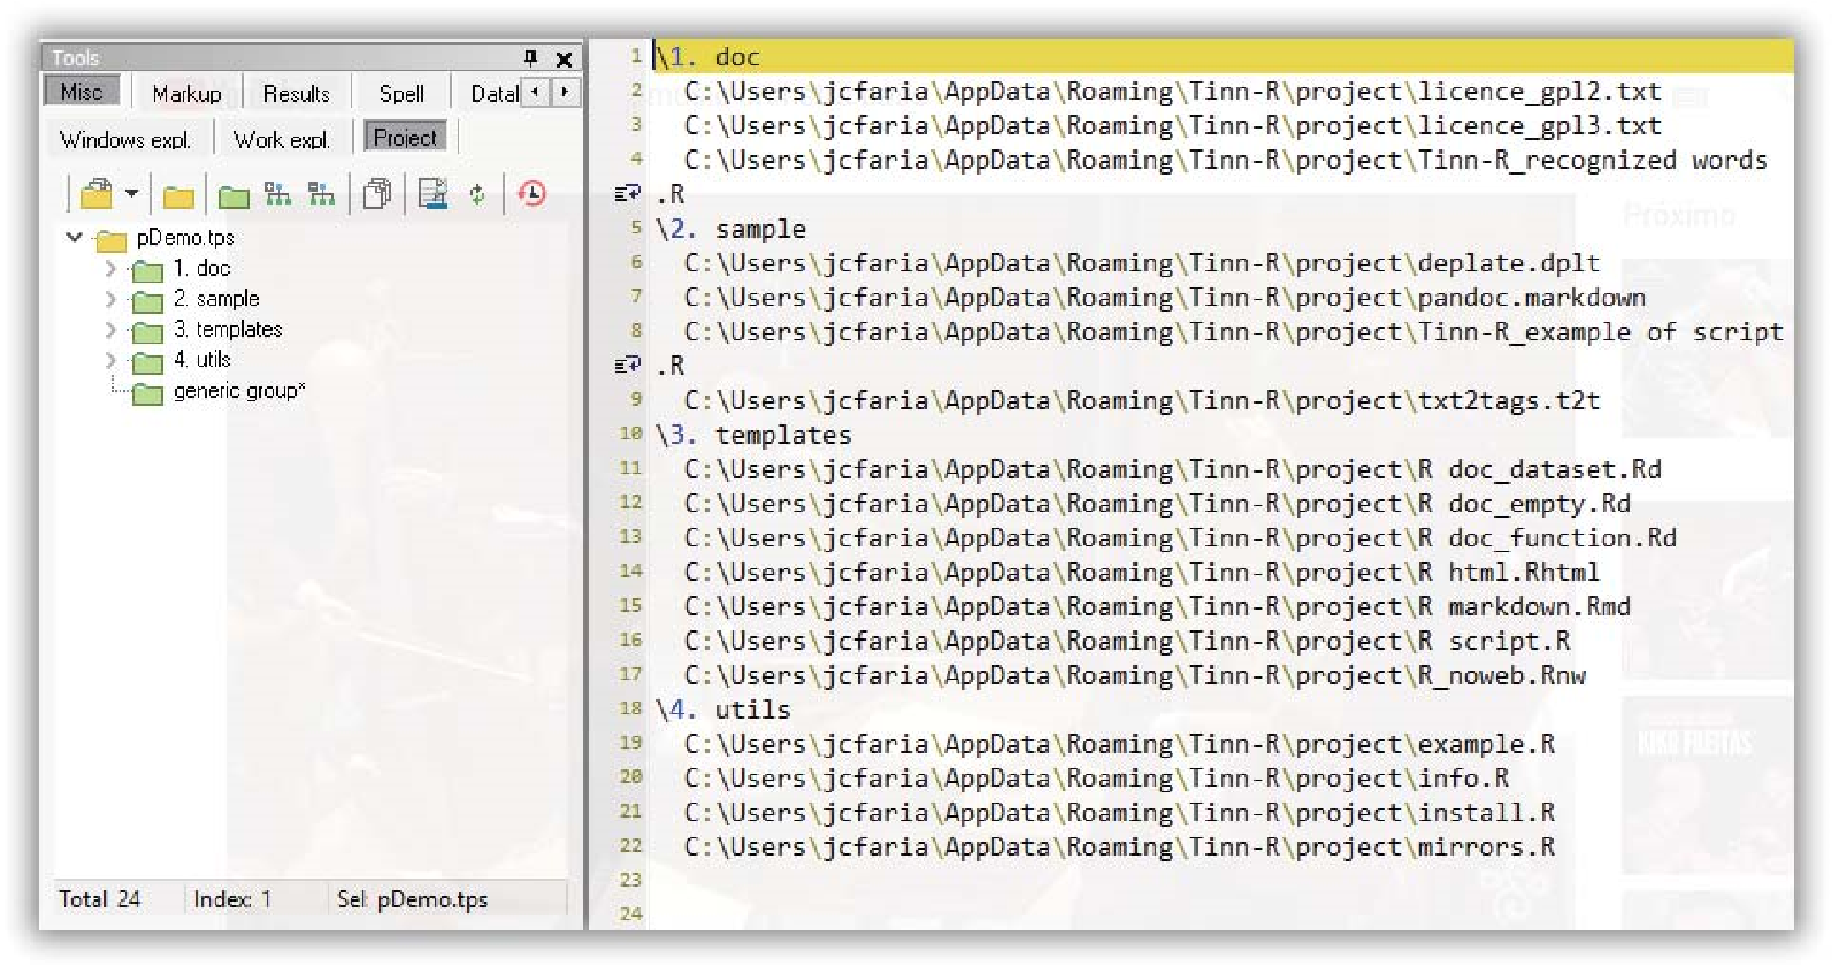

FIGURE 2.46: Tinn-R: Projects in text mode.

For this, with a project (eg pDemo.tps) open in the GUI, the third button from the right on the project: edit (as text file) project taskbar. This opens the text file in the editor. It can then be viewed and edited within the rules for a project file. After saving it (Crtl+S), the second button from left to right will reconstruct the graphical interface of the project from its textual description.

## Submit entire project (or parts) to R interpreter

If you organize your R scripts into projects with a proper group structure, a project pop-up menu option allows the individual file, group, and entire project to be sent to the interpreter. This can be very productive in R package development and more complex data analyses.

## Closing your projects

When finished with the project, or just to back it up as it is, click the smaller yellow-brown file-card icon, then Save.

# 2.14. WORKING WITH MARKS 2.14 WORKING WITH MARKS

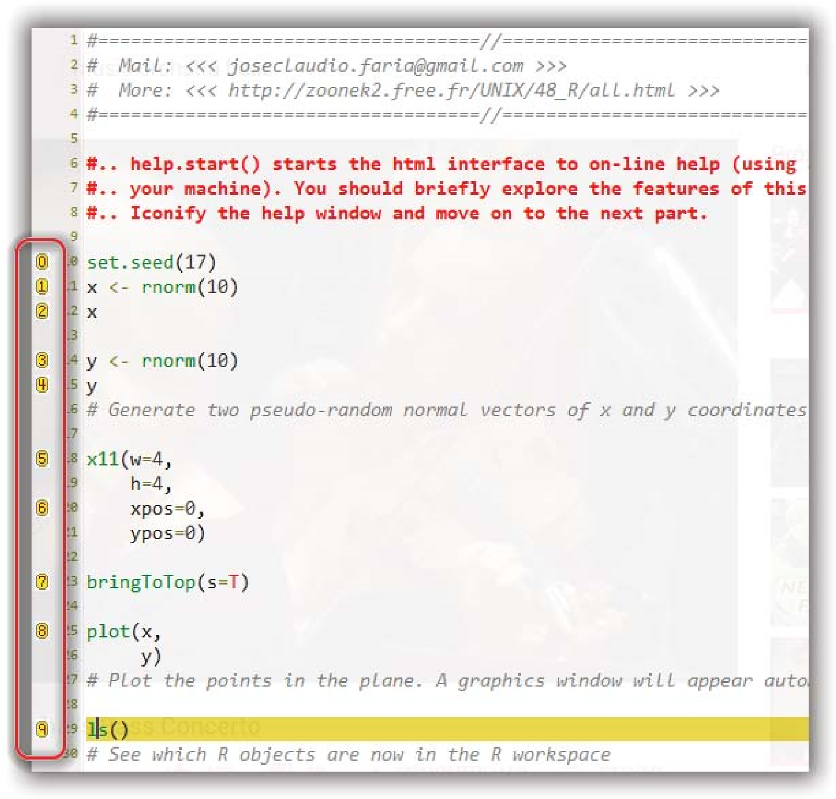

FIGURE 2.47: Tinn-R: Marks.

## Overview

When working with long text or program files, moving from one part of the file to another can be done with the scroll bars, the GoTo line number function (CTRL+G), or under Search, or by searching for specific text strings (CTRL+F). However, these methods become laborious for frequent moves. Placing marks in the text at points you will want to return to is more efficient. Marks are visible as small, circled numbers in the left-side column of the editor, at the start of the line that is marked (Figure 2.47).

Use marks as follows:

1. Insert a new mark at the cursor position: CTRL + SHIFT + 1 + ...+ 9. This allows up to 9 separate marks to be inserted.
2. Go to a mark from somewhere else in the text: CTRL + 1 + ...+ 9. Translocation is immediate.
3. Move a mark from one location to another: eg. for Mark 5. Position the cursor at the new position, then CTRL+SHIFT+5, as in (1). The original position of Mark 5 is lost, and the new position stored.
4. Delete a mark: position the cursor at the existing position using, eg.

CTRL+5. Then re-mark 5, as in (1), with CTRL+SHIFT+5. The number 5 at the beginning of the line disappears to show that mark 5 has been lost and is free for use later.

Basic options are also available, in the Misc taskbar and in the main menu Marks.